# Module 3 (Testing on Live Application)

# • What is RDBMS

* **RDBMS Stands for Relational database management system. RDBMS is the basis for SQL, and for all modern database systems like MS SQL Server, IBM DB2, Oracle, MySQL , and Microsoft Access**.

**•** **What is SQL**

* **SQL is Structured Query Language, which is a computer language for storing, manipulating and retrieving data stored in relation database.**
* **SQL is the standard language for Relation Database System. All relational database management systems like MySQL, MS Access, Oracle, Sybase, Informix, Postgres and SQL server use SQL as standard database language.**

**• Write SQL Commands**

* **DDL – Data Definition language**

|  |  |
| --- | --- |
| **Command** | **Description** |
| **CREATE** | **Creates a new table, a view of table, or other object in database** |
| **ALTER** | **Modifies an existing database object, such as a table** |
| **DROP** | **Deletes an entire table, a view of a table or other object in the database** |
| * **DML – DATA MANIPULATION LANGUAGE**  |  |  | | --- | --- | | **Command** | **Description** | | **INSERT** | **Creates a record** | | **UPDATE** | **Modifies records** | | **DELETE** | **Deletes records** | | |

* **DCL –DATA CONTROL LANGUAGE**

|  |  |
| --- | --- |
| **Command** | **Description** |
| **GRANT** | **Gives a privilege to user** |
| **REVOKE** | **Takes back privileges granted from user** |

* **DQL –DATA QUERY LANGUAGE**

|  |  |
| --- | --- |
| **Command** | **Description** |
| **SELECT** | **Retrieves certain records from one or more tables** |

# • What is join?

* **Join** **statement is used to combine data or rows from two or more tables based on a common field between** **them.**

# • Write type of joins.

* **INNER JOIN : Returns rows when there is a match in both tables.**
* **LEFT JOIN : Returns all rows from the left table, even if there are no matches in the right table.**
* **RIGHT JOIN : Returns all rows from the right table, even if there are no matches in the left table.**
* **FULL JOIN ; Returns rows when there is a match in one of the tables.**

**• How Many constraint and describes it self**

**The available constraints in SQL are:**

* **NOT NULL: This constraint tells that we cannot store a null value in a column. That is, if a column is specified as NOT NULL then we will not be able to store null in this particular column any more.**
* **UNIQUE: This constraint when specified with a column, tells that all the values in the column must be unique. That is, the values in any row of a column must not be repeated.**
* **PRIMARY KEY: A primary key is a field which can uniquely identify each row in a table. And this constraint is used to specify a field in a table as primary key.**
* **FOREIGN KEY: A Foreign key is a field which can uniquely identify each row in a another table. And this constraint is used to specify a field as Foreign key.**
* **CHECK: This constraint helps to validate the values of a column to meet a particular condition. That is, it helps to ensure that the value stored in a column meets a specific condition.**
* **DEFAULT: This constraint specifies a default value for the column when no value is specified by the user.**

# • Difference between RDBMS vs DBMS

|  |  |  |
| --- | --- | --- |
| **DBMS** | | **RDBMS** |
| [**DBMS**](https://www.geeksforgeeks.org/introduction-of-dbms-database-management-system-set-1/)**stores data as file.** | | [**RDBMS**](https://www.geeksforgeeks.org/rdbms-architecture/)**stores data in tabular form** |
| **Data elements need to access individually.** | | **Multiple data elements can be accessed at the same time.** |
| **No relationship between data.** | | **Data is stored in the form of tables which are related to each other.** |
| **Normalization is not present.** | | **Normalization is present.** |
| **DBMS does not support distributed database.** | | **RDBMS supports distributed database.** |
| **It stores data in either a navigational or hierarchical form.** | | **It uses a tabular structure where the headers are the column names, and the rows contain corresponding values.** |
| **It deals with small quantity of data.** | | **It deals with large amount of data.** |
| **Data redundancy is common in this model.** | | **Keys and indexes do not allow Data redundancy.** |
| **It is used for small organization and deal with small data.** | | **It is used to handle large amount of data.** |
| **Not all Codd rules are satisfied.** | | **All 12 Codd rules are satisfied.** |
| **Security is less** | | **More security measures provided.** |
| **It supports single user.** | | **It supports multiple users.** |
| **Data fetching is slower for the large amount of data.** | | **Data fetching is fast because of relational approach.** |
| **The data in a DBMS is subject to low security levels with regards to data manipulation.** | | **There exists multiple levels of data security in a RDBMS.** |
| **Low software and hardware necessities.** | | **Higher software and hardware necessities.** |
| Examples:[XML](https://www.geeksforgeeks.org/xml-basics/), Window Registry, Forxpro, dbaseIIIplus etc. | Examples: [MySQL](https://www.geeksforgeeks.org/architecture-of-mysql/), [PostgreSQL](https://www.geeksforgeeks.org/what-is-postgresql-introduction/), [SQL](https://www.geeksforgeeks.org/what-is-sql/) Server, Oracle, Microsoft Access etc. | |

# • What is API Testing

* **The purpose of API testing id to check the functionality, reliability, performance, and security of the programming interfaces.**
* **In API Testing, instead of using standard user inputs (keyboard) and outputs, you use software to send calls to the API, get output, and note down the system’s response.**
* **API tests are very different from GUI Tests and won’t concentrate on the look and feel of an application.**

# • Types of API Testing

**There are mainly 3 types of API Testing**

* **Open APIs : These types of APIs are publicly available to use like OAuth APIs from Google. It has also not given any restriction to use them. So, they are also known as public APIs.**
* **Partner APIs : Specific rights or licenses to access this type of API because they are not available to the public.**
* **Internal APIs : Internal or private. These APIs are developed by companies to use in their internal systems. It helps you to enhance the productivity of your teams.**

**Tools for API Testing**

* **Postman**
* **Soap UI**
* **J meter**
* **V Rest**

# • What is Responsive Testing?

* **A responsive web design involves creating a flexible web page that is accessible from any device, starting from a mobile phone to a table.**
* **The challenges involved in testing a responsive website how website testing differs from a mobile devices to a computer rules and guidelines to be followed during responsive design testing and Lastly, various tools available to perform responsive testing.**

# • Which types of tools are available for Responsive Testing

* **LT Browser**
* **Lembda Testing**
* **Google Resizer**
* **I am responsive**
* **Pixel tuner**

# • What is the full form of .ipa, .apk

* **.ipa : Iphone Application**
* **.apk : Android Application package**

# • How to create step for to open the developer option mode ON?

* **How to on in one plus nord android**

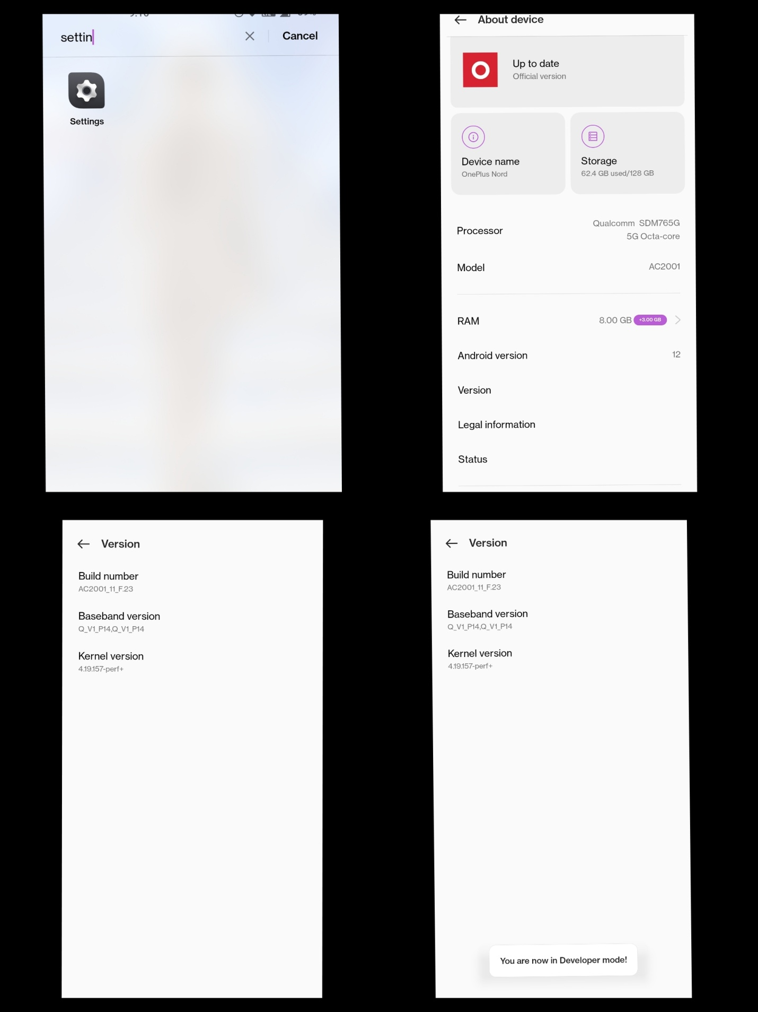

* **How to off developer option**

# C:\Users\HP\Desktop\close developer option.jpg